BÀI THỰC HÀNH SỐ 2

Họ và tên: Thái Bá Chính

MSV: 19574802010127

Câu 1:

import cv2

img = cv2.imread('img.png')

alpha = 0

def get_alpha(pos):

global alpha

alpha = pos

beta = 0

def get_beta(pos):

global beta

beta = pos

cv2.namedWindow('show')

cv2.resizeWindow('show', 500, 100)

cv2.createTrackbar('Tuong phan','show',0,3,get_alpha)

cv2.createTrackbar('Do sang','show',0,100,get_beta)

while True:

output = cv2.convertScaleAbs(img,alpha = alpha, beta = beta)

cv2.imshow('anh',output)

if cv2.waitKey(10) == ord('s'):

cv2.imwrite("anh.png", output)

if cv2.waitKey(10) == ord('q'):

break

cv2.destroyAllWindows()

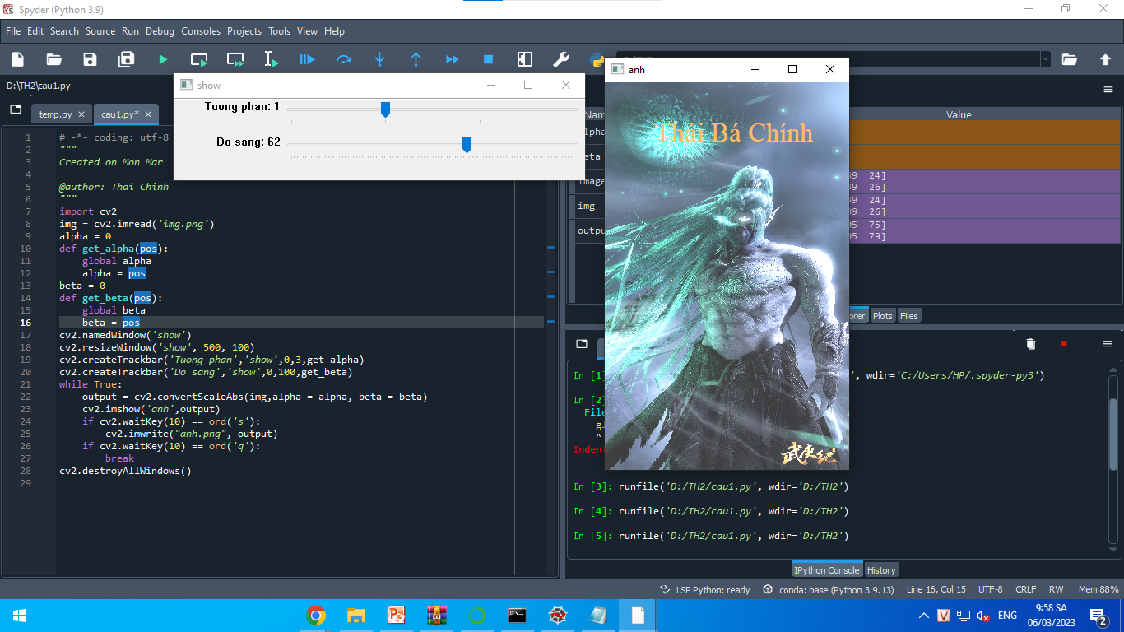

Câu 2:

import cv2

img = cv2.imread('img.png')

[w,h] = img.shape[:2]

img_am_ban = img

a = 0

img_gray = cv2.cvtColor(img, cv2.COLOR_BGR2GRAY )

def convert_to_binary(pos):

global a

a = pos

gray_img = cv2.cvtColor(img, cv2.COLOR_BGR2GRAY )

cv2.namedWindow('Show')

cv2.resizeWindow('Show', 500, 100)

cv2.createTrackbar('Nhi Phan', 'Show', 1,127,convert_to_binary)

while True:

ret, binaryimg = cv2.threshold(gray_img, a, 255, cv2.THRESH_BINARY)

cv2.imshow('Anh', binaryimg)

if cv2.waitKey(10) == ord('s'):

cv2.imwrite("anh-nhi-phan.png", binaryimg )

if cv2.waitKey(10) == ord('a'):

for i in range (w):

for j in range (h):

img_am_ban[i][j] = 255 - img[i][j]

cv2.imwrite("anh-am-ban.png", img_am_ban )

if cv2.waitKey(10) == ord('q'):

break

cv2.destroyAllWindows()

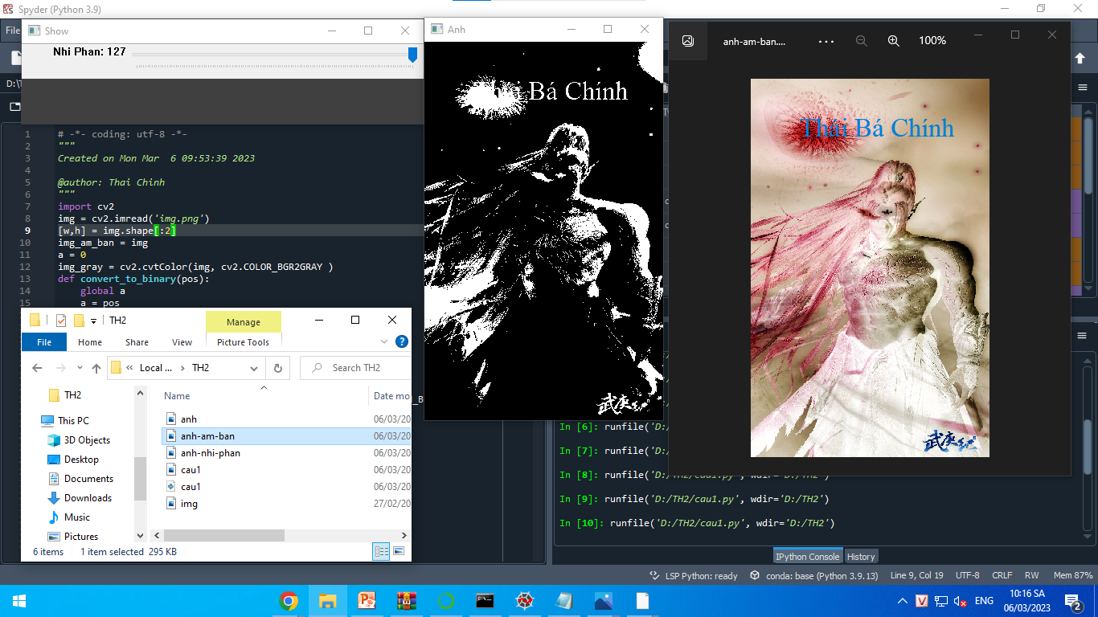

Câu 3:

import cv2

img = cv2.imread('img.png')

alpha = 0

def get_alpha(pos):

global alpha

alpha = pos

beta = 0

def get_beta(pos):

global beta

beta = pos

cv2.namedWindow('show')

cv2.resizeWindow('show', 500, 100)

cv2.createTrackbar('FX','show',1,4,get_alpha)

cv2.createTrackbar('FY','show',1,4,get_beta)

while True:

output = cv2.resize(img, None,fx=0.5*alpha,fy= 0.5*beta, interpolation=cv2.INTER_LINEAR)

cv2.imshow('anh',output)

if cv2.waitKey(10) == ord('q'):

break

cv2.destroyAllWindows()

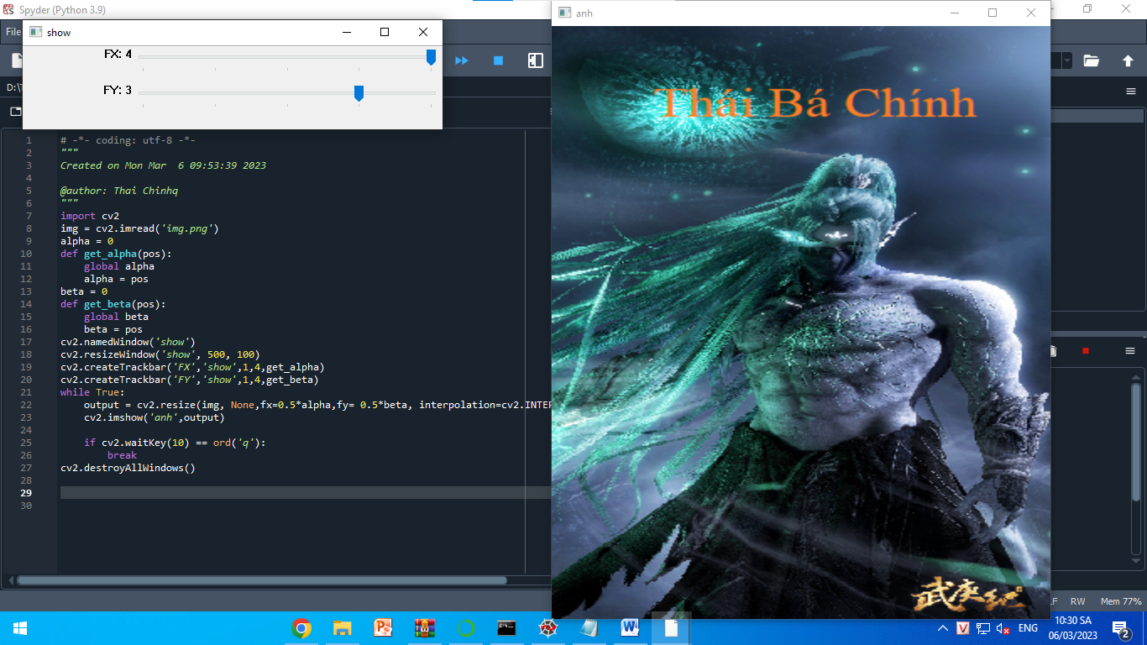

Câu 4:

import cv2

img = cv2.imread('img.png')

w = int(input('Nhap chieu rong: '))

h = int(input('Nhap chieu cao: '))

x_left = int(input('Nhap toa do x goc tren trai: '))

y_left = int(input('Nhap toa do y goc tren trai: '))

x_right = int(input('Nhap toa do x goc duoi phai: '))

y_right = int(input('Nhap toa do y goc duoi phai: '))

img_by_wh = img[0:w, 0:h]

img_toado = img[x_left:x_right, y_left:y_right]

cv2.imshow('cat anh theo chieu dai, chieu rong', img_by_wh)

cv2.imshow('cat anh theo toa do', img_toado)

cv2.waitKey(0)

cv2.destroyAllWindows()

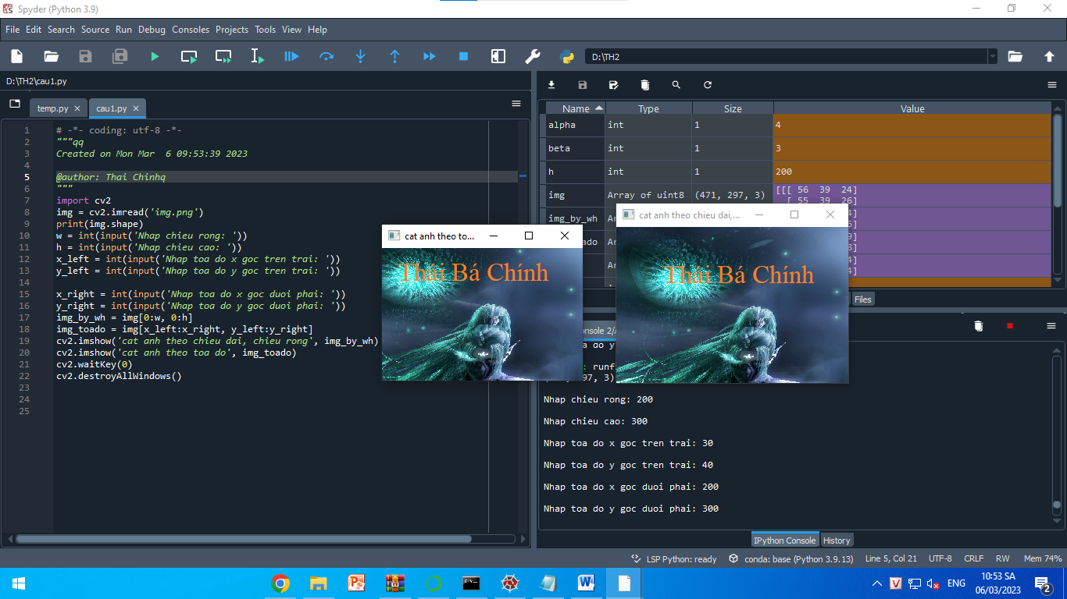

Câu 5:

import cv2

import numpy as np

img = cv2.imread('img.png')

(rows, cols) = img.shape[:2]

tx = 0

def set_tx(pos):

global tx

tx = pos

ty = 0

def set_ty(pos):

global ty

ty = pos

cv2.namedWindow('show')

cv2.resizeWindow('show', 500, 100)

cv2.createTrackbar('TX','show',1,200, set_tx)

cv2.createTrackbar('TY','show',1,200, set_ty)

while True:

M1 = np.array([[1, 0, tx], [0, 1, ty]], dtype=np.float32)

tran1 = cv2.warpAffine(img, M1, (cols, rows))

cv2.imshow('anh',tran1)

if cv2.waitKey(10) == ord('q'):

break

cv2.destroyAllWindows()

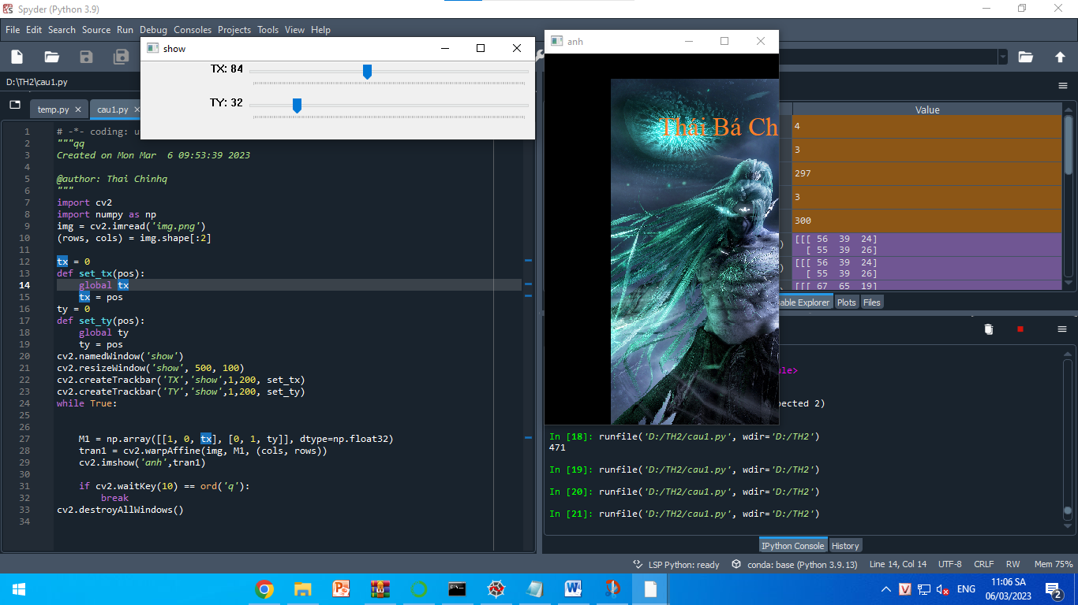

Câu 6:

import cv2

img = cv2.imread('img.png')

(rows, cols) = img.shape[:2]

alpha = 0

def set_alpha(pos):

global alpha

alpha = pos

cv2.namedWindow('show')

cv2.resizeWindow('show', 500, 100)

cv2.createTrackbar('goc quay','show',0,360, set_alpha)

while True:

M = cv2.getRotationMatrix2D(center = (cols/2,rows/2), angle=alpha, scale=1)

ro = cv2.warpAffine(img, M, (cols, rows))

cv2.imshow('anh',ro)

if cv2.waitKey(10) == ord('q'):

break

cv2.destroyAllWindows()

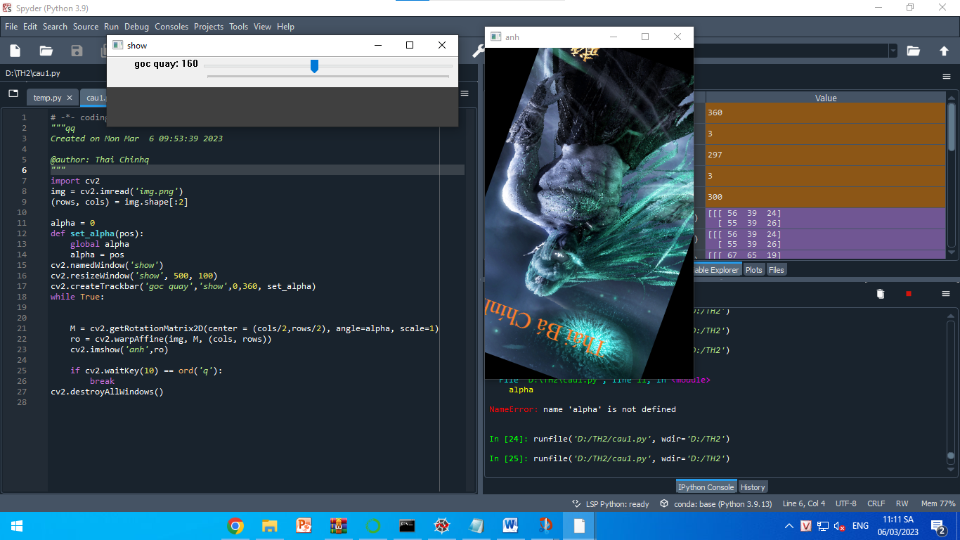

Câu 7:

import cv2

import numpy as np

img = cv2.imread("img.png")

pts1 = np.float32([[10,50],[250,50],[20,250],[250,260]])

pts2 = np.float32([[0,0],[210,0],[0,297],[210,297]])

M = cv2.getPerspectiveTransform(pts1,pts2)

dst = cv2.warpPerspective(img,M,(210,297))

cv2.imshow("results", dst)

cv2.imshow('image', img)

cv2.waitKey(0)

cv2.destroyAllWindows()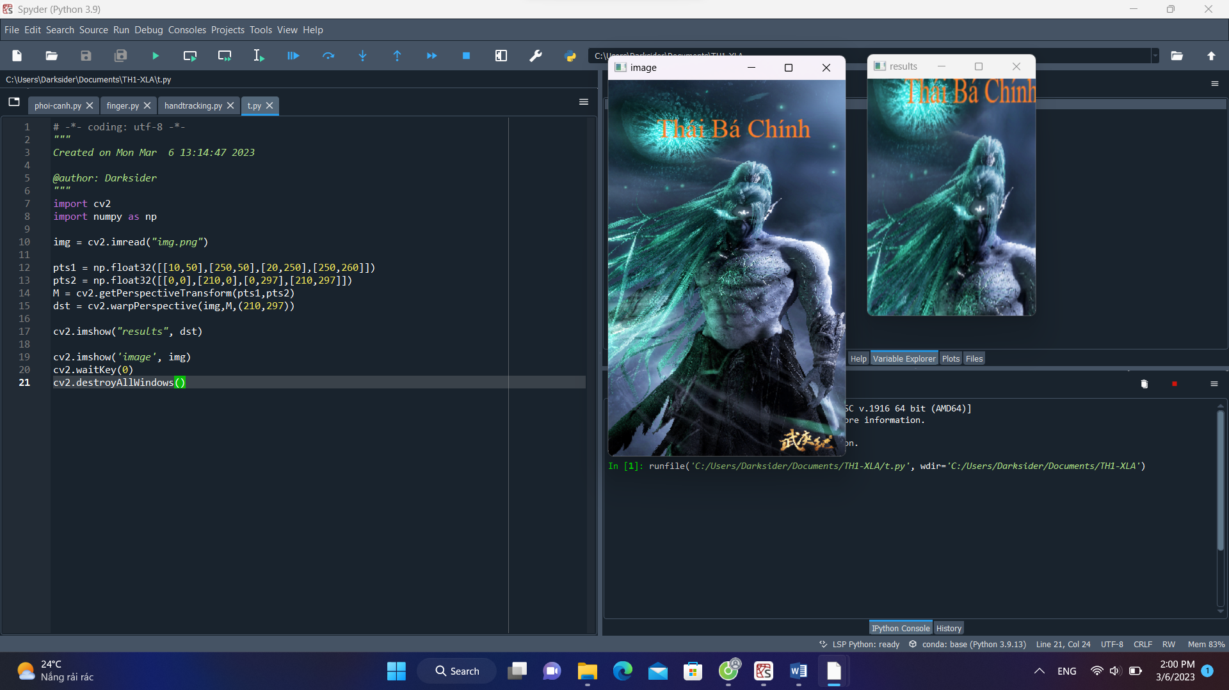

Câu 8:

import cv2

import numpy as np

img = cv2.imread("img.png")

cv2.line(img,(10,10),(200,10),(255,0,0),5)

cv2.rectangle(img,(10,20),(270,100),(0,255,0),3)

cv2.circle(img,(100,200), 63, (0,0,255), -1)

cv2.ellipse(img,(100,350),(100,50),0,0,360,255,-1)

pts = np.array([[10,210],[20,300],[70,400],[200,420]], np.int32)

pts = pts.reshape((-1,1,2))

cv2.polylines(img,[pts],True,(0,255,255))

cv2.putText(img, "Thai Chinh", (10, 400), cv2.FONT_HERSHEY_PLAIN, 3,(255, 0, 255), 3)

cv2.imshow('image', img)

cv2.waitKey(0)

cv2.destroyAllWindows()

